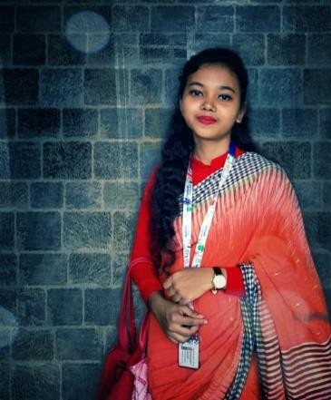Résumé of

Adifa Vuyia Kathi

Address: Pathantola,Dhamrai,Dhaka Cell No: 01787719946

Email Id: adifakathy@gmail.com

.

**Personal Information**

Father’s name : Md.Moshiur Rahman

Mother’s Name : Jibon Nahar Date of Birth : 13-11-1999

Nationality : Bangladeshi (by birth)

Religion : Muslim

Marital Status : Single

Sex : Female

Blood Group : O+

Permanent Address : Pathantola,Dhamrai,Dhaka

# Career Objective

To pursue a challenging career in leading organization that offers opportunities for utilizing

one’s skills

towards the growth of the organization.

# Biography

My interest lays with Communication. I can handle peoples with my dedication. I like to learn new things and with listening carefully and asking the questions I can get to the core of the conversations very quickly.

# Educational Qualification B.sc in CSE

Institution : Daffodil International University

Current semester : 11th semester

Average CGPA : 3.70

# Higher Secondary Certificate (H.S.C) : Science

Institution : Jahangirnagar University School & College

Board : Dhaka Education Board

Result : GPA-5

Year of Passing 2017

# Secondary School Certificate (S.S.C) : Science

Institution : Dhamrai Hardinge High School

Board : Dhaka Education Board

Result : GPA- 5

Year of Passing 2015

# Computer Skill

Operating System : Windows 10, Linux

Office Management : MS-Word, PowerPoint, Excel

Computer language : Programming Language(C), JAVA, Python

Also working in : Web Design, Web Development, Android Development

# Work Experience

* Teacher

ADIFA VUYIA KATHI